Jawaban :

**Soal 1**

1. Table Pembayaran

* PK = Kolom “NoKontrak”
* FK = Kolom “KodeCabang” terhadap Table “Cabang” kolom “KodeCabang”
* FK = Kolom “KodeMotor” terhadap Table “Motor” kolom “KodeMotor”

1. Table Cabang

* PK = Kolom “KodeCabang”

1. Table Motor

* PK = Kolom “KodeMotor”

**Soal 2**

SELECT * FROM dbo.Pembayaran WHERE convert(date, TglBayar) = '2014-10-20'

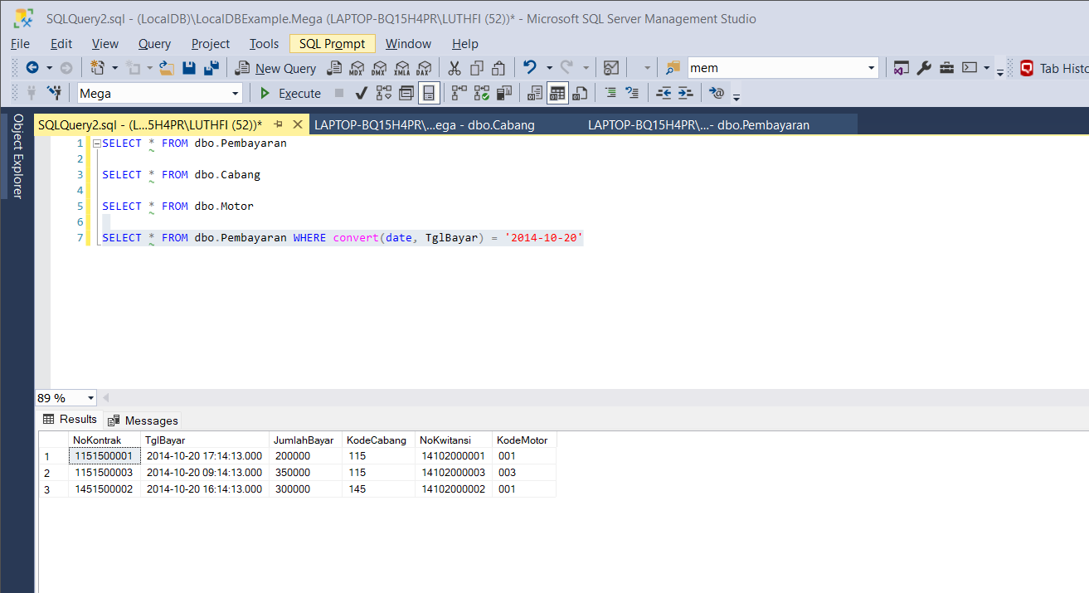

**Soal 3**

INSERT INTO dbo.Cabang(KodeCabang, NamaCabang)

VALUES (200, 'Tangerang')

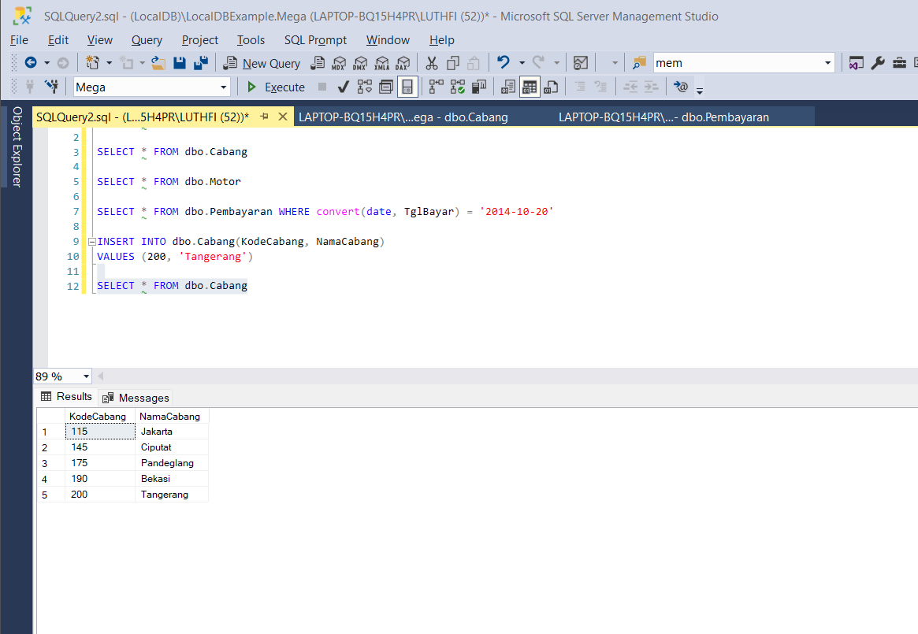

**Soal 4**

UPDATE dbo.Pembayaran SET KodeMotor = '001'

WHERE NoKontrak in (SELECT NoKontrak FROM dbo.Pembayaran

WHERE KodeCabang = (SELECT KodeCabang FROM dbo.Cabang WHERE NamaCabang = 'Jakarta'))

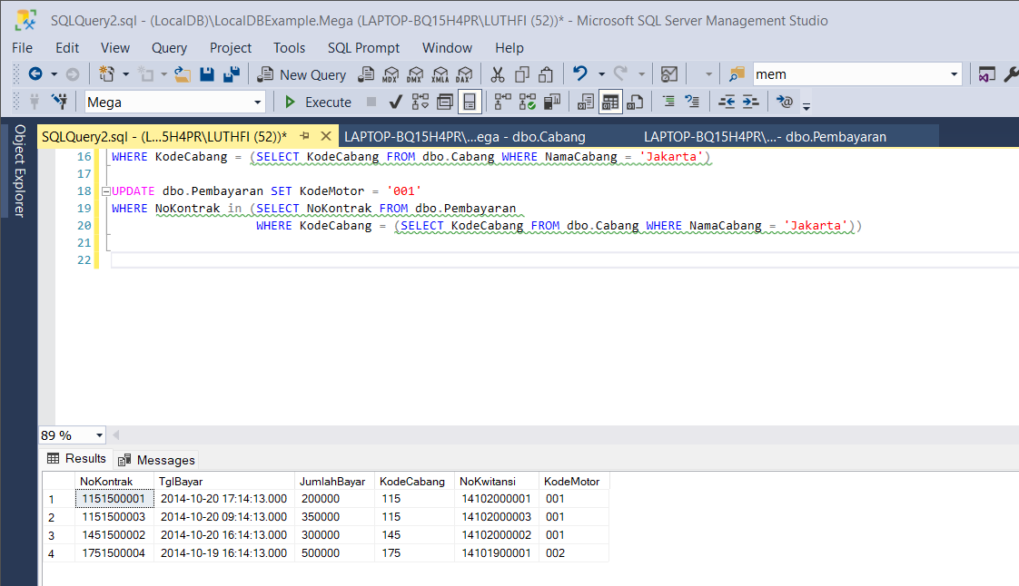

**Soal 5**

SELECT a.NoKontrak, a.TglBayar, a.JumlahBayar, a.KodeCabang, b.NamaCabang, a.NoKwitansi, a.KodeMotor, c.NamaMotor

FROM dbo.Pembayaran a

JOIN dbo.Cabang b ON a.KodeCabang = b.KodeCabang

JOIN dbo.Motor c ON a.KodeMotor = c.KodeMotor

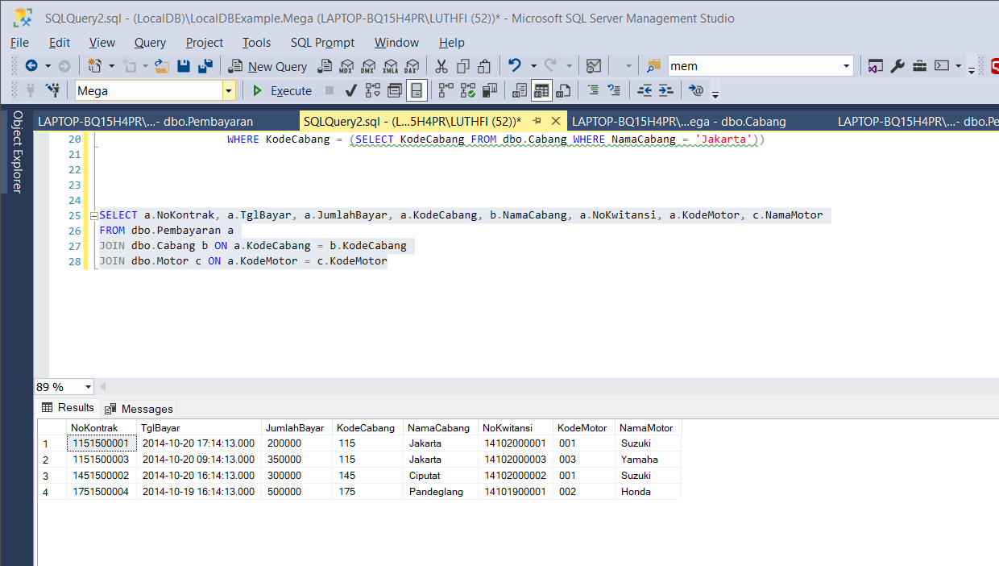

**Soal 6**

SELECT a.KodeCabang, a.NamaCabang, b.NoKontrak, b.NoKwitansi

FROM dbo.Cabang a

LEFT JOIN dbo.Pembayaran b ON a.KodeCabang = b.KodeCabang

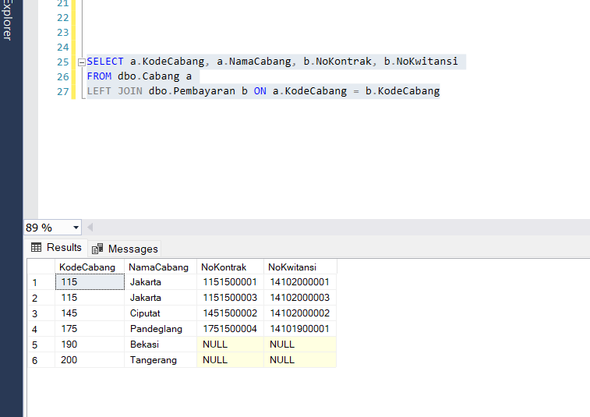

**Soal 7**

SELECT a.KodeCabang, a.NamaCabang, COUNT(b.KodeCabang) AS TotalData,

CASE WHEN SUM(b.JumlahBayar) IS NULL THEN 0

ELSE SUM(b.JumlahBayar) END AS TotalBayar

FROM dbo.Cabang a

LEFT JOIN dbo.Pembayaran b ON a.KodeCabang = b.KodeCabang

GROUP BY a.KodeCabang, a.NamaCabang

